DFD level 0
Include the dpedenceys thay are external entiys

Class diagram (still in progress)
https://lucid.app/lucidchart/c97864cc-da5f-442d-b9e8-f16bd5718434/edit?view_items=xTQrZO6Wuty3%2CKSQrtN6K2TPN%2CcTQrXQOjd5Nd&invitationId=inv_6081b6eb-fd51-4a22-9f45-aa385315285b
hsc ofical
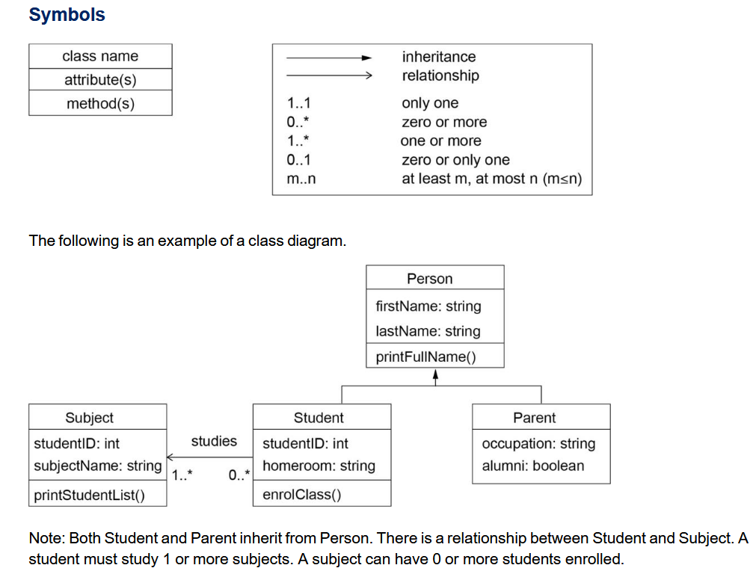
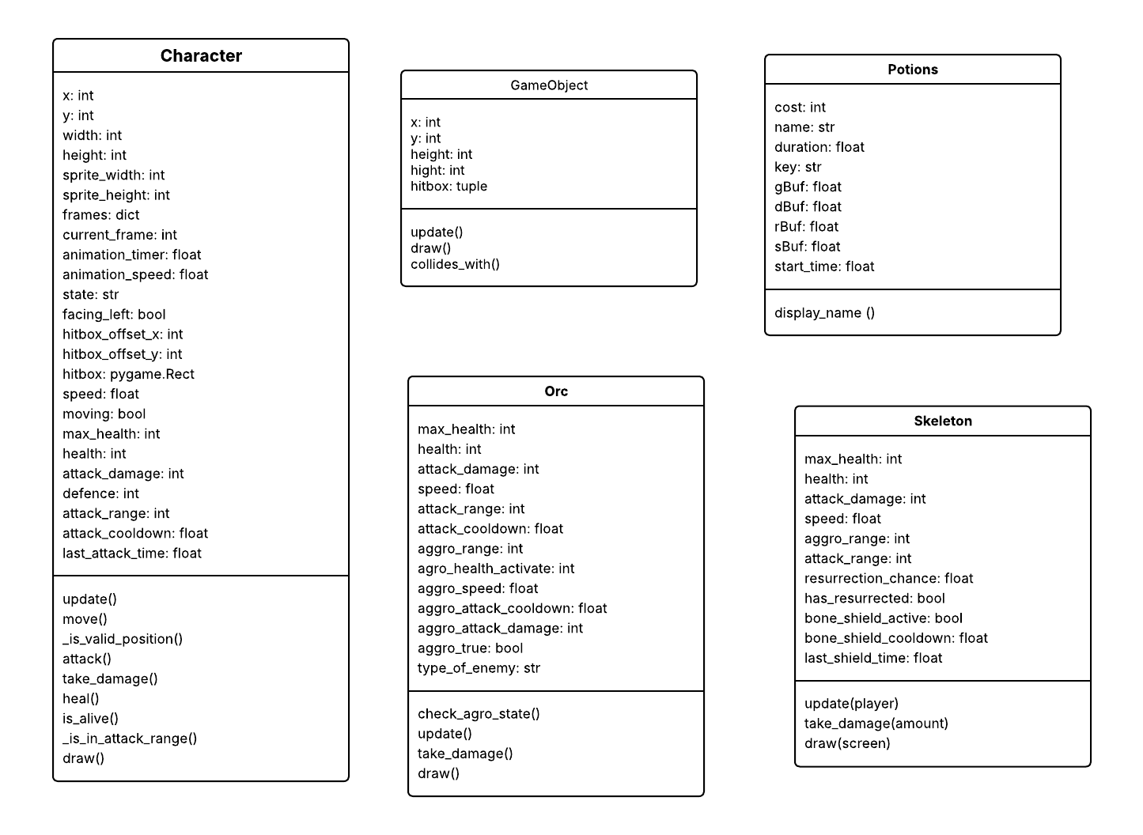
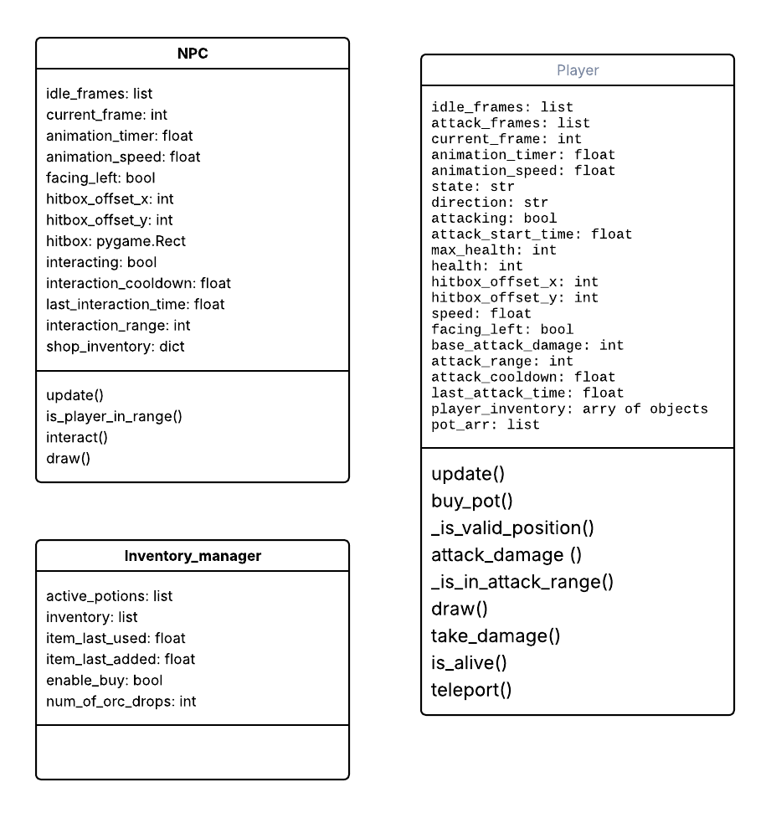
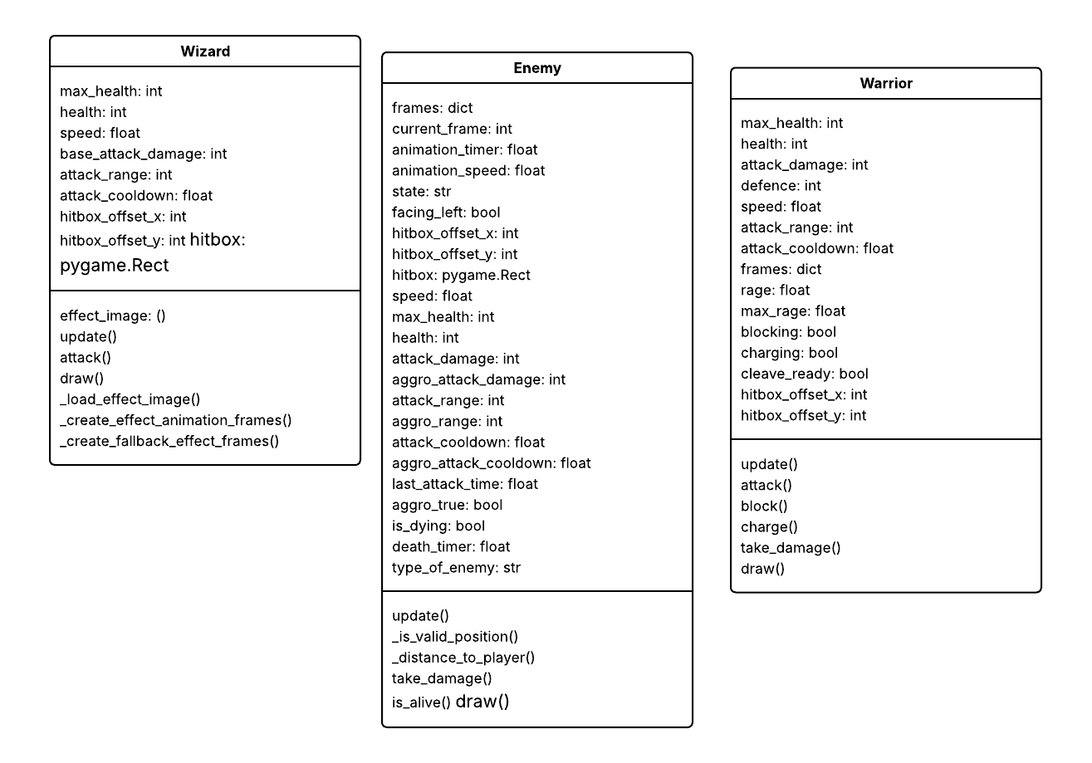

Gann chart
Add a proposed and actual gann chart
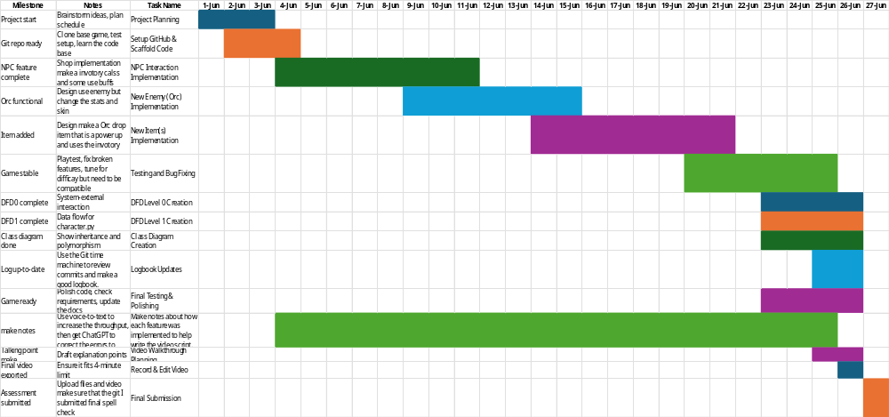
Chat gpt fix spelling and grammar
NOTE: this is still verry rough but am I on the right track

Video rough script / plan
Npc shop
To create the NPC shop, I first needed to create an inventory. I did this by creating a file inventory.py, and then inside that file I created a class. In the subclass, the class was an Inventory class which had methods that allowed me to add and remove inventory items from the inventory and activate them. I also made a Potions class. This allowed me to have a potion with a predefined template of values such as duration and the spicifc buffs that it would change.
Then I made the on-activation of a potion pop the potion from the inventory to the active potion array. Then I made a loop iterate over the array of objects. Each iteration, it went and got the object's property of duration and start time which let me remove it from a acive potions array.
There is a:
buffs = {
"gBuf": 1,
"rBuf": 1,
"dBuf": 1,
"sBuf": 1
}

Then I found the part of the code where the player had the particular gold buff, speed buff, resistance buff, and damage buff used, and I modified it to multiply it by the respective buff. This let me adjust the character's abilities during gameplay.
Once I had worked out how to implement potions, the next step was to work out how to implement the NPC interaction. To do this, I needed to modify the game loop to return a boolean value to the inventory class. This boolean value dictated whether the NPC was within weapons range of the player. If it was, it disabled the ability to use potions, but on the same button bindings that would typically be used to use the potion, it was assigned to buy a potion from the NPC. This used the add_inventory function. This function is different to just appending to the array because it has a time that it was last used. This limits the speed that you can buy off the NPC, reducing and mitigating spamming and accidentally spending all your money on a particular potion which you did not want.

Orc
The orc worked by using the OOP principle of readability to increase the efficiency and speed of development. How the orc was created is: the parent class Enemy had a collection of variables which could be overwritten, so they were overwritten to adjust the functionality to make a unique enemy. To change the skin colour of the orc from skeleton to orc, the same function that was used to assign the skeleton its skin colour was duplicated and modified to produce a function which would give you the correct sprites for the skin colour change. To enable this to happen, the dictionary at the top of the file asset_loader had to be modified to include an orc. So the skeleton dictionary was copied and renamed to orc. Then the create_orc_skin had to be run. This took me about an hour to figure out that it needs to be run—it was one of those bugs which is so mind-numbingly obvious once you solve them. Then I duplicated the get_enemy_frames function and made another copy of it called get_enemy_orc_frames. This method of doing it has a slight drawback as it increases technical debt, but it is significantly faster than having to work out how to make it in one function enemy_frames. This more general function modification was what I attempted first, but I ended up screwing up the code so badly I had to revert via Git.
To test that the asset loader function was working, I renamed the asset loader function for skeleton to the one for orc and the one for orc to skeleton and ran the code. It successfully changed the appearance of the skeleton to look like orcs. This proved to me that my code modification on the asset loader function was successful and I reverted the name changes.
The next thing I did was modify the game loop to include creation of orcs, so I changed the create_enemy function to have a probabilistic modification which had a choice of creating a certain number of orcs to skeleton ratio. This let me create either orcs or skeletons by using these similar and same methods as a skeleton is created, but I could also create an orc. This led to minimal code alterations, reducing the chances of creating bugs.
Once I had an orc functioning as a skeleton with just different abilities, it was time to create an aggro orc.

Adding an item
To begin this process, I started by looking at what was already there and I found the coin drop. This suited my needs very well because a coin was something that an enemy dropped, and a lot of the existing infrastructure was already there for only dropping one upon death of the enemy.
So what I did was I modified the Enemy class to include an enemy_type. This let me do an if statement in the place where the gold coin was created to determine whether or not it would also drop an orc drop. This is an item which levels up the player either through a magician path if it is a wizard or a knight path if it's a knight.
The implementation of this levelling up is done through the buff system which was created for the potion implementation. It adds the orc drop to the inventory of the player then activates it. This orc drop has its properties for the particular amount of improvements that it gives, but it also does specific improvements depending on the keypress. So it will either put your player in a powerful defensive mode or an offensive mode…

VOICE TO TEXT DUMP
Npc shop
To create the MPC shop I first need to create an inventory I did this by creating a file inventory dot PY and then create inside that file I created a class in the subclass the class was a inventory class which had methods that allowed me to add and remove inventory items from the imagery and activate them. I also made a potions class this allowed me to have a potion with predefined template of values such as duration and which particular buffs it would change.

Then I made the on activation of potion pop the potion from inventory 2 the active potion array then I made a loop iterate over the array of objects each iteration it went and got the objects property of duration and start time which was modified when the object was activated. The loop got the summation of the buffs

there is a:
buffs = {
"gBuf":1,
"rBuf":1,
"dBuf":1,
"sBuf":1}

Then I found the part of the code where the player had the particular gold buffs paid buff resistance buff damage buff used and I modified it to multiply it by the respective buf this let me adjust the characters abilities during gameplay

once I had worked out how to implement potion it was the next step to workout how to implement the NBC interaction to do this I needed to modify the game loop to return a boolean value to the inventory class this boolean back value dictated whether the NPC was within weapons range of the player if it was it disabled the ability to use potions but on the same button bindings that would typically be used to use the potion it was assigned to by a potion from the NPC and this used the ad inventory function this function is different to just depending to the array because it has a time that it was last used this limits the speed that you can buy off the NBC reducing and mitigating spamming and accidentally spending all your money on a particular potion which he did not want

Orc
The awk worked by using the oop principle of readability to increase the efficiency and speed of development. How the orc was created is the parent class enemy had a collection of variables which could be overwritten so they were overwritten to adjust the functionality to make a unique enemy. To change the skin colour of the ork from skeleton to orc the same function that was used to assign this skeleton its skin colour was duplicated and modified to produce a function which would give you the correct sprites for the skin colour change to enable this to happen the dictionary at the top of the file asset loader had to be modified to include a orc so the skeleton dictionary was copied and renamed to orc. Then the create or skin had to be ran this took me about an hour to figure out that it needs to be ran it was one of those bugs which is so mind numbingly obvious once you solve them. Then I duplicated the get enemy frames function and made another copy of it called get enemy orc frames this method of doing it has a slight drawback as it increases technical debt but it is significantly faster than having to workout how to make it in one function enemy frames this more general function modification was what I attempted first but I ended up screwing up the code so badly I had to revert by via git.

To test that the asset loader function was working I renamed the asset loader function for skeleton to the one for orc and the one for orc for skeleton and ran the code and it successfully changed the appearance of the skeleton to look like Hawks this proved to me that my code modification on the asset loader function was successful and I reverted the name changes.

The next thing I did was I needed to modify the game loop to include creation of books so I changed the create enemy function too have a probabilistic modification which had a choice of creating a certain number of orcs to skeleton ratio. This let me create either orcs or skeletons by using these similar and same methods as a skeleton is created but I could also create an awk this led to minimal code alterations reducing the chances of creating bugs.

Once I had a walk functioning as a skeleton with just different abilities it was time to create an aggro's orc.
Adding a item
To begin this process I started by looking at what was already there and I found the coin drop this suited my needs very well because a coin was something that an enemy dropped and a lot of the existing infrastructure was already there for only dropping one upon death over the enemy

So what I did was I modified the enemy clause to include a enemy type this let me do an if statement in the place where the gold coin was created to determine whether or not it would also drop a orc drop this is a item which levels up the player either through a magician path if it is a wizard or a night path if it's a knight

the implementation of this levelling up is done through the buff system which was created for the potion implementation is it adds the walk drop to the inventory of the player then activates it this awk drop has its properties for the particular amount of improvements that it gives but it also does specific improvements depending on the keypress so it'll either put your play in a powerful defensive mode or an offensive mod

